DEBATE ON DANGEROUS DRIVING (Alok Sharma MP)
Westminster Hall, Thursday 17th September, 3.00 – 4.30pm

A briefing from CTC, the national cycling charity

Introduction

- CTC, the national cycling charity, was founded in 1878 and has 68,000 members and supporters. CTC’s central mission is to make cycling a safe, accessible, enjoyable and ‘normal’ activity for people of all ages and abilities. Our interests cover cycling both as a form of day-to-day transport and as a leisure activity, which can deliver health, economic, environmental, safety and quality of life benefits both for individuals and society. We represent the interests of current and would-be cyclists on public policy matters, as well as organising projects to enable diverse people (including those from disadvantaged groups) to discover the benefits and joys of cycling. We organise cycling events and provide a range of information and legal services. CTC’s President is the broadcaster Jon Snow.

- CTC has given oral evidence to a number of parliamentary inquiries in recent years, including the Commons Transport Committee’s inquiry on the Government’s road safety strategy, a more recent inquiry on Cycle safety, and the 2013 ‘Get Britain Cycling’ inquiry conducted by the All Party Parliamentary Cycling Group (APPCG, which CTC supports along with its allies in the Active Travel Alliance). We strongly endorsed the inquiry’s 18 recommendations, which led the Government to propose a draft Cycling Delivery Plan. Our campaigning then helped secure cross-party backing for a legal commitment to a Cycling and Walking Investment Strategy, which was written into the Infrastructure Act 2015.

- CTC welcomed the Conservative Manifesto commitment to “reduce the number of cyclists and other road users killed or injured on our roads every year.”

CTC’s Road Justice Campaign

CTC’s Road Justice Campaign (www.roadjustice.org.uk) seeks to ensure the legal system acts as an effective deterrent to bad driving, thereby improving road safety for all road users, and for cyclists in particular.

- The Road Justice campaign’s objectives are:

- To ensure thorough police investigations of all road traffic collisions involving injury and death, including appropriate support and information for road crash victims;
- To ensure the police and prosecution make appropriate charging and prosecution decisions;
- To ensure sentences deter bad driving while reflecting the severity of driving offences.

- An overview of CTC’s views on strengthening road traffic law and enforcement is provided by our campaigns briefing on road traffic law and enforcement.

- CTC’s three Road Justice campaign booklets (all downloadable from www.roadjustice.org.uk/road-justice-reports) document the stories of individuals whose cases highlight common failings of the police, prosecutors, and the courts and sentencing respectively. These failings routinely result in drivers who have clearly caused danger being handed down derisory sentences or not prosecuted at all. This reinforces the perception that our roads are lawless places and that the legal system is either unable or unwilling to defend the safety of pedestrians and cyclists, i.e. those whose use of the roads causes least harm (in terms of safety as well as congestion and the environment) yet who are also among the most vulnerable on our roads.

- The recommendations for improvements made in our three Road Justice booklets have been well received by police forces, Police and Crime Commissioners, the Ministry of Justice (MoJ), the Crown Prosecution Service and Sentencing Council. However all three areas of the law remain under-resourced.

Roads policing

- Roads policing is a vital road safety measure and a necessary complement to driver awareness campaigns. Its main aim is to deter people from causing danger in the first place – though the police also have key roles in investigating possible road crimes, making some charging decisions and providing victim support. The effectiveness of policing as a road safety measure is provided in CTC’s briefing on roads policing and enforcement (see page 4 of www.ctc.org.uk/sites/default/files/file_public/traffic-policing4frv1.pdf).

- CTC’s Road Justice campaign has for several years been highlighting the fact that roads policing has suffered disproportionate cuts in recent years, compared with overall police numbers. Traffic police officer numbers fell by 37% from 2002/3-2013/14, from almost 7,000 uniformed officers down to just 4,356. During that same period, total policing levels fluctuated a little from year to year, but not to this degree: police officers in March 2014 numbered about 3.5% less than in 2003.

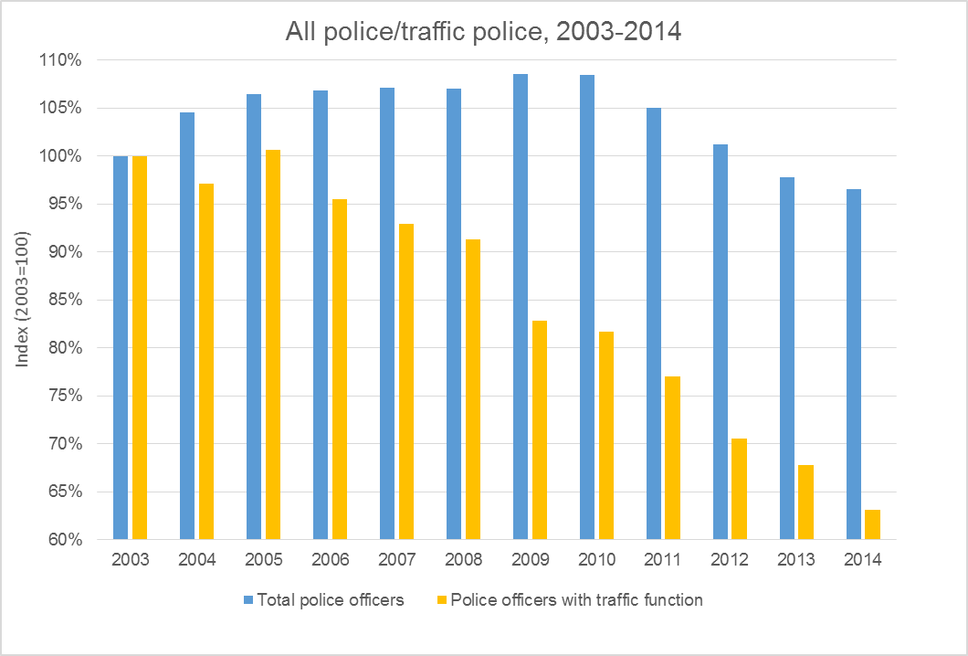
Changes in total police officer numbers, 2003-14 (for sources, see CTC’s roads policing and enforcement briefing)

- Meanwhile the risk per mile travelled of a serious cycling injury has been worsening since 2007, reversing previous positive trends. Other road users (notably pedestrians) have also seen a worsening road safety record over roughly the same time period. Although cyclist fatality numbers have remained fairly steady, the number of cyclist casualties has risen by 26% compared with the 2005-9 average, while fatal and serious cyclist casualties have risen by 46%. Some of this increase will simply be due to increased cycle use – and the scale of this increase depends on whether you use data from the Government’s roadside counts or from the National Travel Survey (which uses travel diary surveys). Either way though, the risk per mile travelled of a serious or fatal cycling injury has risen over this period by between 7% and 14%. This is a reversal of positive trends prior to 2005 – i.e. cycle use had been rising while cyclist casualty rates had been falling.

Changes to cyclist casualty rates: 2013 compared with 2005-9 average.

Casualty rates per billion miles cycled | 2013 | 2005-9 ave | % change
Using traffic count data:
- Fatal & serious injuries | 1036 | 910 | 14%
- Injuries of all severities | 6187 | 5,915 | 5%
Using travel diary data:
- Fatal & serious injuries | 1056 | 988 | 7%
- Injuries of all severities | 6304 | 6,441 | -2%
Source: Reported Road Casualties Great Britain 2014, table RAS30013

- Though we cannot be sure of this, CTC suspects that cuts to roads policing may be a significant contributor to these adverse outcomes. Other road users’ safety has also worsened over this period, but cyclists’ safety has suffered disproportionately.

Review of road traffic offences and sentencing

- Under the previous Government, former Justice Secretary Chris Grayling MP announced a review of road traffic offences and sentencing, largely in response to CTC’s Road Justice campaign. CTC strongly welcomed this at the time and subsequently had a very positive meeting with Ministry of Justice (MoJ) officials. Moreover, in a previous Commons debate on the sentencing of dangerous drivers (also called by Alok Sharma MP), the Minister (Mike Penning MP) promised widespread consultation on the issue of sentencing. However we have heard no word of it since the general election earlier this year. We therefore urge MPs to use the Westminster Hall debate to seek information about the process and timescales for the review of road traffic offences and sentencing.

- CTC believes that the aims of this review should be:

- To end the tendency of police, prosecutors and the courts to treat driving which has apparently caused obviously foreseeable danger as merely “carelessness”; and
- To relate sentencing more closely to the offender’s standard of driving, rather than to the outcome of the offence – and specifically to strengthen the role of driving bans (rather than custodial sentences) as the main sanction for those who have driven ‘dangerously’ without necessarily having done so recklessly or with dangerous intent. Those who appear to have driven recklessly or with dangerous intent should still receive custodial sentences, as should those who have flouted previous driving bans.

- CTC also wishes to see a strengthening of existing Sentencing Guidance, which says that state that ‘the fact that the victim of a causing death by driving offence was a particularly vulnerable road user is a factor that should be taken into account when determining the seriousness of an offence’. In practice this rarely appears to happen.

- Options for achieving the above outcomes are discussed in CTC’s campaigns briefing on the legal framework and sentencing (see www.ctc.org.uk/sites/default/files/file_public/legal-framework-sentencing4drv.pdf, page 6). Given the long history of well-intentioned but unsuccessful efforts to create an effective legal framework for tackling bad driving, we believe an open debate among relevant stakeholders is vital for achieving a positive outcome.

Driving bans

- CTC is particularly concerned that the likelihood of a driver being banned has evidently fallen in recent years. Even for convictions involving fatalities (where driving bans are supposed to be mandatory), the proportion of offenders receiving driving bans fell from 94% in 2003 to 80% in 2013. In other words, 1 in 5 drivers who have killed do not now face driving bans.

- CTC has also found evidence that:

- Between 2009 and 2013, there has been a 38% drop in the number of drivers being disqualified, even though there was only a 17% fall in road casualties;
- According to a parliamentary answer in 2013, the courts chose not to disqualify 7,842 of the 12,470 (63%) drivers with more than 12 points on their licence;
- Ministry of Justice figures show that bans were only given for 12% of offences (79,236 offences/71,740 drivers). Two thirds of these were for drink/drug driving;
- Even when drivers are banned, it is very rarely for over three years, and many are banned only until they’ve passed their driving test again – 65% of bans are less than 6 months;
- Only one in 37 drivers convicted of careless driving (an offence for which a ban is discretionary) was banned;
- The percentage of dangerous driving convictions resulting in a driving ban fell from 92% in 2011 to 89% in 2013;
- The number of lifetime bans for dangerous driving fell from nine in 2011 to two in 2013.

- CTC believes that a driving licence is not, and should not be seen as, an automatic right. Drivers are licenced providing they demonstrate that they can drive safely, given that the use of motor vehicles is inherently hazardous to other road users. They should forfeit that right if there is evidence that they have failed in their safety duties to others.

- Recent reporting in the Independent on Sunday indicated the Government is currently seeking to make it easier to gain a driving licence, while also making it harder to use. CTC is concerned about the wider implications this could have for road safety and how this fits with a manifesto pledge to reduce killed and serious injuries on UK roads.

Sentencing for drivers who cause multiple deaths

- We are aware of the concerns of the bereaved families of John Moreland and Kris Jarvis, two cyclists killed by Alexander Farrar-Walter in the constituency of Alok Sharma MP. Farrar-Walter was disqualified from driving at the time of the collision, was two-and-a-half times over the legal drink-drive limit, and was driving at 70mph in a 30mph zone. He also had a string of previous convictions. He was convicted of causing the cyclists' deaths by dangerous driving and sentenced to ten years and three months in prison and a 15 year driving ban – see www.roadjustice.org.uk/case-study/two-cyclists-killed-car-purley-thames-130214.

- Their plight led to a very well-supported petition which called for a change in sentencing guidelines so that a driver convicted of causing more than one death by dangerous driving receives a consecutive sentence for each death, rather than concurrent sentences as in this case. Whilst CTC strongly sympathises with the families’ desire to change the law, we fear that this specific proposal could have unintended consequences. It would in effect mean that a driver who had killed one victim would receive half the sentence of an equally irresponsible driver who killed two. It could therefore lead to weaker sentencing in far more cases than those that would be strengthened by it.

- There is, however, a strong argument that Farrar-Walter should have received a lifetime driving ban, which, if flouted, would land him immediately back in prison. The precedent for lifetime bans in similar cases was set in the case of Nicholas Lovell, who was sentenced to ten and a half years and a lifetime ban for causing the deaths of Clare and Ross Simons by dangerous driving in January 2013. That case has strong parallels with the Farrar-Walter case.

CTC, the national cycling charity
September 2015

See www.ctc.org.uk/news/2012-07-17/road-safety-inquiry-highlights-lack-of-government-leadership-on-cycling
See www.ctc.org.uk/news/ctc-urges-mps-to-demand-action-and-funding-to-‘get-britain-cycling’
See www.ctc.org.uk/get-britain-cycling and www.ctc.org.uk/ministers-police-and-jon-snow-appear-appcg
See www.ctc.org.uk/news/get-britain-cycling-report-recommends-%C2%A310-head-year-funding-for-cycling
See p15 https://s3-eu-west-1.amazonaws.com/manifesto2015/ConservativeManifesto2015.pdf
Home Office (2015). Police workforce, England and Wales, 30 September 2014, table 6: www.gov.uk/government/statistics/police-workforce-england-and-wales-30-september-2014-data-tables
See www.gov.uk/government/uploads/system/uploads/attachment_data/file/357309/ras30013.xls.
See www.ctc.org.uk/news/government-announces-full-review-of-driving-offences-and-penalties.
See www.ctc.org.uk/news/20141105-still-date-dangerous-driving-sentencing-review.
See www.ctc.org.uk/news/1-5-motorists-banned-causing-death
For sources, see CTC’s briefing on the Legal framework and sentencing policy: www.ctc.org.uk/sites/default/files/file_public/legal-framework-sentencing4drv.pdf.
See www.independent.co.uk/news/uk/home-news/conservatives-plot-a-motoring-revolution-draft-report-reveals-biggest-reform-to-regulations-since-driving-test-introduced-in-1935-10478419.html
See www.roadjustice.org.uk/case-study/man-charged-two-cases-death-dangerous-driving-after-two-cyclists-killed-bristol-hit-and-r.

